Alexandria/Arlington

Resource Recovery Facility

|  |  |
| --- | --- |
| **E:\Alexandria Arlington\Alexandria Arlington - Q2FY14\November 2013\PB120006.JPG** | **E:\Alexandria Arlington\Alexandria Arlington - Q2FY14\November 2013\PB120029.JPG** |
| **E:\Alexandria Arlington\Alexandria Arlington - Q2FY14\November 2013\PB120012.JPG** |

Second Quarter 2014

Summary Operating Report

**Prepared by:**



**HDR Engineering, Inc.**

**5426 Bay Center Drive, Suite 400**

**Tampa, Florida 33609**

Table of Contents

Section No. Page No.

1.0 Purpose of Report 4

2.0 Executive Summary 4

3.0 Facility Inspection and Records Review 6

4.0 Facility Operations 8

5.0 Facility Availability 19

5.1 Facility Operations 20

5.2 Utility and Reagent Consumptions 24

6.0 Environmental 25

6.1 Nitrogen Oxide Emissions 26

6.2 Sulfur Dioxide Emissions 26

6.3 Carbon Monoxide Emissions 26

6.4 Opacity 26

6.5 Daily Emissions Data 26

6.6 Ash System Compliance 27

6.7 Steam Production Issues 28

7.0 Facility Maintenance 29

7.1 Safety 29

7.2 Facility Housekeeping 30

APPENDIX A FACILITY CEMS DATA 31

APPENDIX B PHOTOS 35

List of Tables

Table No. Page No.

Table 1: Summary of Audit Report Deficiencies 7

Table 2: Quarterly Performance Summaries 13

Table 3: Jurisdictional vs. Non-Jurisdictional Waste Delivery 14

Table 4: Quarterly Facility Unit Availabilities 20

Table 5: Boiler Downtime – Q2FY14 21

Table 6: Turbine Generator Downtime – Q2FY14 22

Table 7: Facility Utility and Reagent Consumptions 24

Table 8: Quarterly Environmental Excursions 25

Table 9: Comparison of Statistical Results and Regulatory Thresholds for Metal Analytes 27

Table 10: Facility Housekeeping Ratings – November 2013 30

Table 11: Unit #1 Monthly Summary for Reportable Emissions Data 32

Table 12: Unit #2 Monthly Summary for Reportable Emissions Data 33

Table 13: Unit #3 Monthly Summary for Reportable Emissions Data 34

List of Charts

Chart No. Page No.

Chart 1: Tons of Waste Processed 8

Chart 2: Tons of Ash Produced per Ton of Waste Processed 9

Chart 3: Ferrous Recovery Rate 10

Chart 4: Steam Production 10

Chart 5: 12-Month Rolling Steam Production 11

Chart 6: Steam Production Rate 12

Chart 7: Calculated Waste Heating Value 12

Chart 8: Cumulative Total Waste Delivery 15

Chart 9: Gross Electrical Generation 15

Chart 10: Gross Conversion Rate 16

Chart 11: Net Conversion Rate 17

Chart 12: Net Conversion Rate 17

Chart 13: Gross Turbine Generator Conversion Rate 18

Chart 14: Net Turbine Generator Conversion Rate 19

Chart 15: Ash Toxicity Characteristic Leaching Procedure (TCLP) Results 27

Chart 16: Quarterly Ash Test Results 28

List of Figures

Figure No. Page No.

Figure 1: Turbine Generator No. 2 Major Overhaul – Upper Half 15th Stage Diaphragm – removed for inspection 36

Figure 2: Turbine Generator No. 2 Major Overhaul -overhead photo of removed rotor 36

Figure 3: Turbine Generator No. 2 Major Overhaul – various stages of packing removed for inspection 36

Figure 4: Turbine Generator No. 2 Major Overhaul – isometric view of removed rotor 36

Figure 5: Turbine Generator No. 2 Major Overhaul – scaffolding in place for Main Condenser No. 2 work 36

Figure 6: Turbine Generator No. 2 Major Overhaul – Contractors removing lower diaphragms for inspection 36

Figure 7: Turbine Generator No. 2 Major Overhaul – Upper Turbine Shell Removed 37

Figure 8: Turbine Generator No. 2 Major Overhaul – Turbine controls being upgraded – face removed for rewiring 37

Figure 9: Turbine Generator No. 2 Major Overhaul – Upper Half 8th Stage Diaphragm – removed for inspection 37

Figure 10: Turbine Generator No. 2 Major Overhaul – upper shell, rotor, diaphragms, and packing removed 37

Figure 11: Turbine Generator No. 2 Major Overhaul – General View – Lower shell casing and studs 37

Figure 12: Turbine Generator No. 2 Major Overhaul – various packing removed for inspection 37

Figure 13: General Facility view from across Eisenhower Avenue 38

Figure 14: Citizen’s Drop-off Roll-off nearly full 38

Figure 15: General Facility view from entrance roadway 38

Figure 16: Spider cracking and concrete repairs showing continued degradation (Deficiency Item No. 1 – July 2010) 38

Figure 17: White Goods Roll-Off 38

Figure 18: Inbound Scale – No Issues Observed 38

Figure 19: Ash Trailers – No Issues Observed 39

Figure 20: Cooling Towers – Photos from SDA Penthouse 39

Figure 21: Auxiliary Burner – No Issues Observed 39

Figure 22: Tipping Floor – No Issues Observed 39

Figure 23: Main Vibratory Conveyor – No Issues Observed 39

Figure 24: Ferrous Metal Load-Out – No Issues Observed 39

**Definition of Abbreviations & Acronyms**

|  |  |
| --- | --- |
| Abbreviation/Acronym | Definition |
| APC | Air Pollution Control |
| Apr | April |
| Aug | August |
| Avg | Average |
| Btu | British thermal unit |
| CAAI | Covanta Alexandria Arlington, Inc. |
| CEMS | Continuous Emissions Monitoring System |
| CO | Carbon Monoxide |
| Dec | December |
| Feb | February |
| FMG | Facility Monitoring Group |
| FY | Fiscal Year |
| gal | Gallon |
| GAT | Guaranteed Annual Tonnage |
| HCl | Hydrochloric (Hydrogen Chlorides) |
| HDR | HDR Engineering Inc |
| ID | Induced Draft |
| Jan | January |
| Jul | July |
| Jun | June |
| klbs | Kilo-pounds (1,000 lbs) |
| kWhr | Kilowatt hours (1,000 watt-hours) |
| lbs | Pounds |
| LOA | Letter of Agreement |
| Mar | March |
| Max | Maximum |
| May | May |
| Min | Minimum |
| MSW | Municipal Solid Waste |
| MWhr | Megawatt hours |
| No | Number |
| NOV | Notice of Violation |
| Nov | November |
| NOx | Nitrogen Oxide |
| Oct | October |
| OSHA | Occupational Safety and Health Administration |
| PDS | Potomac Disposal Services |
| ppm | Parts per million |
| ppmdv | Parts per million dry volume |
| PSD | Prevention of Significant Deterioration |
| Q1 | First Quarter |
| Q2 | Second Quarter |
| Q3 | Third Quarter |
| Q4 | Fourth Quarter |
| RE | Reportable Exempt |
| RNE | Reportable Non-Exempt |
| SDA | Spray Dryer Absorber |
| Sep | September |
| SO2 | Sulfur Dioxide |
| TCLP | Toxicity Characteristic Leaching Procedure |
| VADEQ | Virginia Department of Environmental Quality |
| WL | Warning Letter |
| yr | Year |
| YTD | Year to date |

Alexandria/Arlington Waste-to-Energy Facility

Second Quarter 2014 Summary Operating Report

# Purpose of Report

HDR Engineering, Inc. (HDR) was given authorization by the Facility Monitoring Group (FMG) to conduct quarterly inspections and provide quarterly monitoring reports regarding the operation and maintenance of the Alexandria/Arlington Waste-to-Energy Facility (Facility) for the 2013 calendar year. This report is prepared for the second quarter of the 2014 fiscal year and summarizes Facility operations between October 1, 2013 and December 31, 2013. This report identifies the fiscal year beginning on July 1, 2013 as FY14 and the quarter beginning on October 1, 2013 as Q2FY14.

This report is based upon the experience HDR has in the waste-to-energy industry, upon site observation visits and previous reports provided by HDR, and upon data provided by Covanta Alexandria / Arlington, Inc. (CAAI), the Facility operator.

# Executive Summary

CAAI operated the Facility in an acceptable manner and in accordance with established waste-to-energy industry practices during Q2FY14. The operation of the Facility, maintenance, safety, and overall cleanliness continue to be above average. Environmental performance was acceptable with one (1) reportable environmental excursion throughout the quarter, which is summarized in Section 6.0 of this report.

During Q2FY14, the Facility experienced one (1) instance of unscheduled downtime for the boilers totaling 14.3 hours, and two (2) instances of unscheduled downtime for the turbine generators totaling 25.8 hours. Beginning October 13, 2013, Boiler No. 1 experienced 105.0 hours of downtime for scheduled maintenance. Beginning October 28, 2013 Boiler No. 3 experienced 87.0 hours of downtime for scheduled maintenance. Beginning October 27, 2013 Turbine Generator No. 2 experienced 614.8 hours of downtime for a major overhaul. The boilers experienced eight (8) instances of standby time totaling 328.2 hours, and the turbine generators experienced five (5) instances of standby time totaling 222.7 hours during the quarter. A detailed listing of downtime is provided in Section 5.1 of this report.

Average waste processed during the quarter was 927.0 tons per day, or 95.1% of nominal facility capacity. Waste deliveries averaged 929.3 tons per day, which is 0.2% higher than the burn rate. The capacity utilization of 95.1% compares favorably to industry averages, which are generally in the 88% to 92% range.

Performance trends for various measurements are presented in Section 4. In general, the Facility continues to demonstrate reasonable consistency in month to month performance throughout the most recent three year period tracked for detailed comparisons.

During the quarter, MSW processed increased 0.6% from the corresponding quarter in FY13; steam production decreased 5.2%, and electricity generated (gross) decreased 3.2% from the corresponding quarter in FY13. The decrease in steam generation was attributable to the decrease (6.4%) in the calculated average waste heating value, as well as more (246.5 additional hours) scheduled, unscheduled, and standby downtime. The decrease in gross electrical generation in Q2FY14 as compared to Q2FY13 is attributable to the decrease in steam production as well as more (264.8 additional hours) scheduled, unscheduled, and standby downtime experienced by the turbine generators.

# Facility Inspection and Records Review

In November 2013, HDR met with the Facility management and other plant personnel to discuss Facility operations and maintenance, acquire Facility data and reports, perform an independent visual inspection of the operating Facility, photograph areas of interest, and perform a review of recent Facility activity. This visit was coordinated with the scheduled FMG Meeting. At the time of the visit, HDR reviewed CAAI records, discussed performance issues with CAAI staff, and provided a verbal report and performance statistics. HDR maintains a running tabulation of the status of corrective actions and plant performance trends. CAAI provides the following documents for each month:

* Facility Monthly Operating Reports
* Monthly Continuous Emissions Monitoring System (CEMS) Reports

Table 1 summarizes maintenance, repair, and plant condition issues reported during this and prior audit reporting periods. An “A” indicates an issue of the highest priority and worthy of immediate attention. Such items are usually safety or operability issues. A “B” indicates that the issue needs to be dealt with as quickly as possible, but is not urgent. These items will usually result in a process improvement or will help avoid future “urgent” issues. A “C” indicates that the issue should be dealt with at the earliest convenience, but is not a priority issue. This category might include issues related to aesthetics, non-urgent maintenance, or housekeeping improvements which are not safety related.

Table 1: Summary of Audit Report Deficiencies

*A is highest priority & demands immediate attention: B needs attention, but is not urgent; C can be addressed at earliest opportunity & is not urgent.

| Item No. | Audit Report Deficiencies | Issue Reported | Priority* | Resolution/Status | Date Resolved | Open / Closed |
| --- | --- | --- | --- | --- | --- | --- |
| 1 | Spider cracking at scale entry area | July 2010 | C | Repair |  | Open |
| 2 | Tipping Floor siding damaged | July 2012 | C | Repair siding |  | Open |
| 3 | Pothole at truck entry roadway | May 2012 | C | Repair |  | Open |
| 4 | Emergency lights not working in SDA Penthouse No. 3 | August 2013 | A | Replace/Repair emergency lighting | November 2013 | Closed |

# Facility Operations

Monthly operating data provided by CAAI indicates that 85,286 tons of MSW were processed during Q2FY14, and a total of 85,500 tons of MSW including 866 tons of Special Handling Waste were received. Total ash production during the quarter was 17,833 tons, which represents 20.9% of the waste processed. The average uncorrected steam production rate for Q2FY14 was 3.0 tonssteam/tonwaste, and 5.8% less than the corresponding quarter in FY13. The decrease in this metric is attributable to the decrease (6.4%) in the calculated average waste heating value that was experienced during the quarter, as compared to the corresponding quarter in FY13.

Chart 1: Tons of Waste Processed

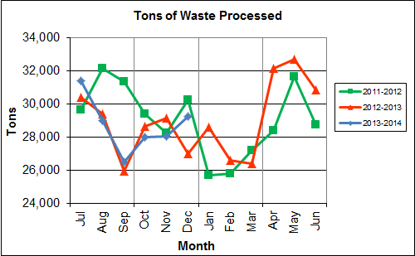

Chart 1 illustrates that Q2FY14 waste processed was higher (0.6%) than the corresponding quarter Q2FY13. CAAI reported that 432 tipping floor/MSW internal inspections were conducted during the quarter and five (5) notices of violation (NOV) were issued to drivers for the following:

* October – Three (3) NOV were issued by CAAI for:
  + Unbuckling turn buckles prior to entering the tipping floor
  + Dumping metal onto the tipping floor and leaving the site
  + Entering the tipping floor prior to being signaled in by the tipping floor operator
* November – One (1) NOV was issued for opening the tailgate on the entrance ramp
* December – One (1) NOV was issued for dragging trash onto the street

Chart 2: Tons of Ash Produced per Ton of Waste Processed

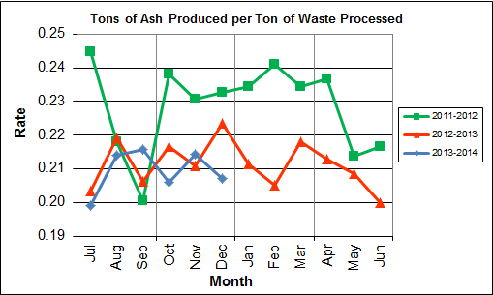

Chart 2 illustrates that ash production rates in Q2FY14 are lower (3.7%) at 20.9% of processed waste, compared to the corresponding quarter in FY13 when the ash production rate was 21.7% of processed waste. It appears that the ash production trend line has stabilized at approximately the 21.0% level, which is significantly lower than industry averages. This is attributed largely to the implementation of the semi-dry ash discharger modifications by CAAI, with the result that ash shipped to disposal has lower moisture content.

Chart 3: Ferrous Recovery Rate

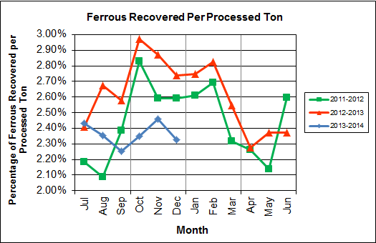

Chart 3 depicts the monthly ferrous metal recovery rate as a percentage of processed MSW tonnage. In Q2FY14, 2,027 tons of ferrous metals were recovered, which is 16.6% lower than the corresponding quarter in FY13 and equivalent to 2.4% of processed waste. CAAI reports that the significant decrease in ferrous metal recovery is attributable to the aging shell of the ferrous magnet, which was replaced during an outage in December 2013.

Chart 4: Steam Production

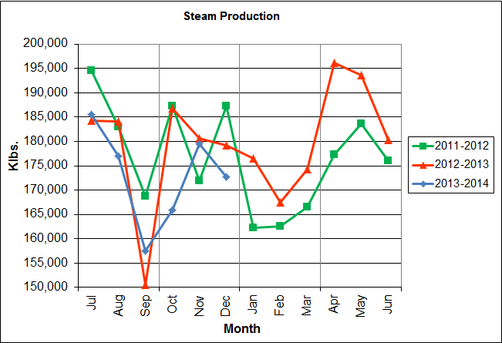

In Chart 4, the total steam production for Q2FY14 was 517,968 klbs., or 5.2% lower than the corresponding quarter in FY13. The decrease in steam production is attributable to the increase (246.5 additional hours) of scheduled, unscheduled, and standby downtime experienced by the boilers, as well as the lower (6.4%) calculated average waste heating value during the quarter.

Chart 5: 12-Month Rolling Steam Production

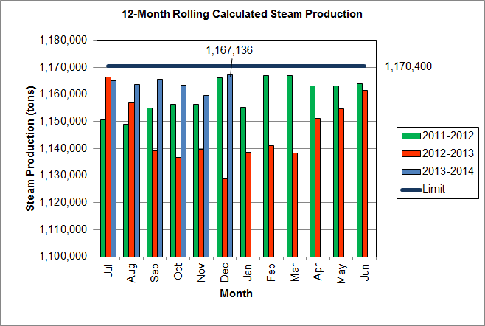

Chart 5 depicts the 12-month rolling steam production total for the period ending in December 2013. According to the Title V permit, the annual steam production for the Facility shall not exceed 1,170,400 tons on the basis of an average value of 3.34 lbs of steam per lb of MSW processed, calculated monthly as the sum of each consecutive 12 month period. The Facility was in compliance with the 12-month rolling steam production total every month in the quarter. The 12-month rolling total for steam production ending in December 2013 was 1,167,136 tons which is 99.7% of the limit.

Chart 6: Steam Production Rate

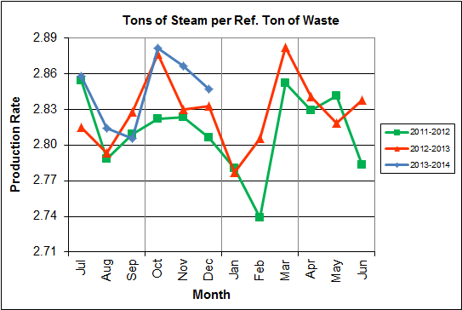

In Chart 6, the conversion of raw waste tonnages into “reference tons” is another way of analyzing steam production, and helps to determine whether changes are related to boiler performance or to fuel issues. “Reference tons” are adjusted to account for the calculated average fuel heating value, so that lower Btu fuel raw tonnages are adjusted upwards and vice versa. In Q2FY14 this metric tracked higher (0.6%), at 2.86 tonssteam/tonref, than the corresponding quarter in FY13.

**Chart 7: Calculated Waste Heating Value**

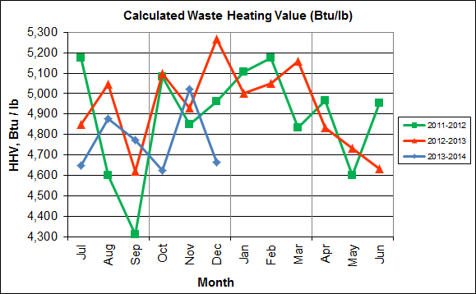

Chart 7 illustrates that Q2FY14 calculated average waste heating value was lower (6.4%) at 4,771Btu/lb than the corresponding quarter Q2FY13, which averaged 5,098 Btu/lb.

Table 2: Quarterly Performance Summaries

|  |  |  |  |  |  |  |  |  |
| --- | --- | --- | --- | --- | --- | --- | --- | --- |
| Month | | Waste Processed (tons) | Waste Diverted  (tons) | Ash Shipped  (tons) | Special Handling (Supplemental)  (tons) | Ferrous Recovered  (tons) | Steam Produced (klbs) | Net Electrical Generation  (kWhr) |
| **Q2FY12** | **Quarterly Totals** | **87,883** | **0** | **20,550** | **51** | **2,348** | **546,465** | **38,983** |
| October-11 | 29,386 | 0 | 6,997 | 15 | 832 | 187,371 | 13,314 |
| November-11 | 28,233 | 0 | 6,512 | 15 | 732 | 171,864 | 12,178 |
| December-11 | 30,264 | 0 | 7,041 | 21 | 784 | 187,230 | 13,491 |
| **Q2FY13** | **Quarterly Totals** | **84,822** | **0** | **18,391** | **664** | **2,429** | **546,639** | **34,177** |
| October-12 | 28,661 | 0 | 6,205 | 25 | 852 | 186,789 | 8,225 |
| November-12 | 29,144 | 0 | 6,146 | 234 | 837 | 180,656 | 12,898 |
| December-12 | 27,017 | 0 | 6,040 | 405 | 740 | 179,194 | 13,054 |
| **Q2FY14** | **Quarterly Totals** | **85,286** | **0** | **17,833** | **866** | 2,027 | **517,968** | **33,068** |
| October-13 | 27,989 | 0 | 5,763 | 410 | 658 | 165,840 | 11,198 |
| November-13 | 28,043 | 0 | 6,008 | 188 | 689 | 179,483 | 9,705 |
| December-13 | 29,254 | 0 | 6,062 | 268 | 680 | 172,645 | 12,165 |
| **FY14 YTD Totals** | | **172,170** | **0** | **36,000** | **2,336** | **4,070** | **1,037,939** | **68,703** |
| **FY13 Totals** | | **347,790** | **0** | **73,446** | **2,665** | **9,063** | **2,154,201** | **148,366** |
| **FY12 Totals** | | **348,455** | **0** | **79,424** | **336** | **8,474** | **2,121,209** | **149,919** |

Table 2 presents the production data provided to HDR by CAAI for Q2FY14 on both a monthly and quarterly basis. For purposes of comparison, data for Q2FY12 and Q2FY13 are also shown, as well as FY12, FY13 and FY14 year-to-date (YTD) totals.

In comparing quarterly totals, the data shows:

* More waste was processed in Q2FY14 than Q2FY13, and less than Q2FY12
* Less steam was generated in Q2FY14 than Q2FY13 and Q2FY12
* Less electricity was generated in Q2FY14 than Q2FY13 and Q2FY12
* Significantly more supplemental waste was received in Q2FY14 than Q2FY13 and Q2FY12.

Please note the total steam generation figures presented in Table 2 do not correlate with the annual steam production limit from the Facility Permit; such limits apply on a 12-month rolling average monthly basis, and not a fiscal year basis. It is also worth noting that the quantity of waste processed during Q2FY14 was limited by the steam production permit restrictions, with “standby time” used to stay just under the rolling average each month (refer to Chart 5).

Table 3: Jurisdictional vs. Non-Jurisdictional Waste Delivery

|  |  |  |  |  |  |  |  |  |  |  |  |  |  |  |
| --- | --- | --- | --- | --- | --- | --- | --- | --- | --- | --- | --- | --- | --- | --- |
|  |  | **Jul** | **Aug** | **Sep** | **Oct** | **Nov** | **Dec** | **Jan** | **Feb** | **Mar** | **Apr** | **May** | **Jun** | **Totals** |
| **FY11** | **Jurisdiction waste toward GAT** | 18,201 | 19,320 | 18,100 | 18,244 | 17,812 | 17,394 | 16,316 | 15,212 | 18,279 | 18,596 | 20,355 | 19,382 | 217,213 |
| **Spot Waste tons** | 13,996 | 13,917 | 11,696 | 9,336 | 10,177 | 11,441 | 12,968 | 7,016 | 8,459 | 10,177 | 12,947 | 9,657 | 131,786 |
| **Supplemental Waste** | 8 | 17 | 12 | 13 | 6 | 13 | 14 | 34 | 25 | 29 | 26 | 6 | 203 |
| **MSW Totals** | **32,205** | **33,254** | **29,808** | **27,593** | **27,995** | **28,848** | **29,298** | **22,262** | **26,763** | **28,803** | **33,328** | **29,044** | **349,202** |
|  |  |  |  |  |  |  |  |  |  |  |  |  |  |  |
| **FY12** | **Jurisdiction waste toward GAT** | 18,112 | 20,021 | 19,304 | 17,796 | 17,523 | 17,211 | 16,202 | 14,952 | 17,430 | 18,338 | 20,138 | 18,361 | 215,381 |
| **Spot Waste tons** | 8,901 | 13,623 | 13,303 | 9,788 | 11,976 | 11,900 | 10,276 | 10,697 | 10,283 | 10,029 | 11,333 | 10,177 | 132,295 |
| **Supplemental Waste** | 10 | 10 | 34 | 15 | 15 | 21 | 12 | 22 | 15 | 23 | 68 | 91 | 336 |
| **MSW Totals** | **27,023** | **33,654** | **32,641** | **27,599** | **29,514** | **29,132** | **26,490** | **25,672** | **27,729** | **28,390** | **31,539** | **28,629** | **348,012** |
|  |  |  |  |  |  |  |  |  |  |  |  |  |  |  |
| **FY13** | **Jurisdiction waste toward GAT** | 19,413 | 18,357 | 16,632(2) | 17,625(3) | 18,838(4) | 16,195 | **-** | **-** | **-** | **-** | **-** | **-** | 107,058 |
| **Spot Waste tons** | 10,516 | 11,326 | 10,610 | 10,317 | 9,330 | 9,558 | **-** | **-** | **-** | **-** | **-** | **-** | 61,656 |
| **City Waste** | **-** | **-** | **-** | **-** | **-** | **-** | 1,683(1) | 1,287 | 1,444 | 2,382 | 2,286 | 1,919 | 11,000 |
| **County Waste** | **-** | **-** | **-** | **-** | **-** | **-** | 2,442(1) | 2,100 | 2,372 | 3,381 | 3,932 | 3,309 | 17,536 |
| **Municipal Solid Waste** | **-** | **-** | **-** | **-** | **-** | **-** | 25,019(1) | 23,637 | 21,661 | 27,066 | 25,794 | 24,930 | 148,107 |
| **Supplemental Waste** | 151 | 11 | 80 | 25 | 234 | 405 | 363 | 365 | 76 | 403 | 281 | 271 | 2,665 |
| **MSW Totals** | **29,928** | **29,683** | **27,241** | **27,942** | **28,167** | **25,753** | **29,507** | **27,388** | **25,552** | **33,231** | **32,293** | **30,429** | **348,022** |
|  |  |  |  |  |  |  |  |  |  |  |  |  |  |  |
| **FY14** | **City Waste** | 2,065 | 1,693 | 1,702 | 1,924 | 1,566 | 1,780 |  |  |  |  |  |  | 10,731(2) |
| **County Waste** | 3,459 | 3,079 | 2,784 | 3,091 | 2,707 | 2,802 |  |  |  |  |  |  | 17,923(2) |
| **Municipal Solid Waste** | 26,167 | 23,604 | 22,034 | 23,354 | 21,879 | 25,531 |  |  |  |  |  |  | 142,568(2) |
| **Supplemental Waste** | 546 | 676 | 248 | 410 | 188 | 268 |  |  |  |  |  |  | 2,336(2) |
| **MSW Totals** | **32,237** | **29,053** | **26,768** | **28,779** | **26,340** | **30,380** |  |  |  |  |  |  | **173,558(2)** |
| **Note (1): Beginning January 2013, the method in which waste was classified was modified as compared to prior periods due to change in contractual obligations and plant ownership**  **Note (2): Values indicated are year to date (YTD) totals** | | | | | | | | | | | | | | |

Chart 8: Cumulative Total Waste Delivery

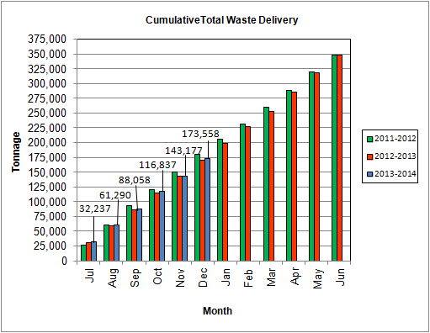

Depicted in Chart 8, for the period ending in December 2013; cumulative total waste delivery was 2.3% more compared to the same period in FY13.

Chart 9: Gross Electrical Generation

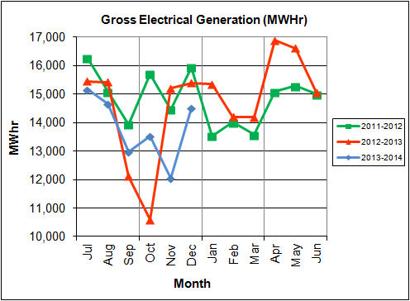

During Q2FY14, the Facility generated 40,089 MWhrs (gross) of electricity compared to Q2FY13 generation of 41,183 MWhrs (gross), a 2.7% decrease. The decrease in gross electrical production is attributable to the increased downtime (264.8 hours) experienced by the turbine generators in comparison to the downtime experienced during the corresponding quarter in FY13. The majority of the downtime experienced during Q2FY14 was for the Turbine Generator No. 2 Overhaul which lasted 614.8 hours in October and November 2013.

Note that the 3-year low of gross electrical production experienced in October 2012 was due to Turbine Generator No. 1 experiencing 494.5 hours of downtime for scheduled maintenance. Evidence of the downtime experienced by the Turbine Generators is also apparent in Chart Nos. 10 through 14, including sharp spikes in the trends for the months of October 2012 and 2013 as well as November 2013 when the Overhauls were conducted on Turbine Generator Nos. 1 and 2.

Chart 10: Gross Conversion Rate

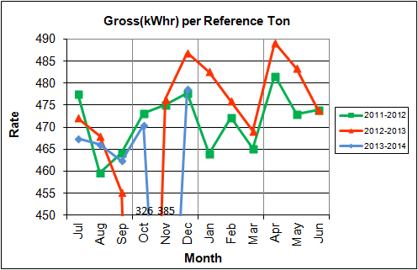

As shown in Chart 10, the average gross electrical generation per reference ton of refuse processed during Q2FY14 was 445 kWhr, which is 3.5% higher than the corresponding quarter in FY13. Since this calculated value uses reference or normalized tonnages of waste, it should cancel the effect of MSW heating value (Btu content) variability.

Chart 11: Net Conversion Rate

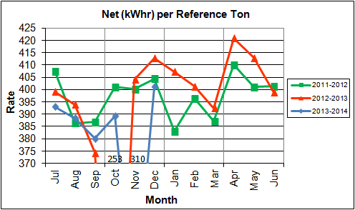

Chart 11 depicts the normalized net power (gross minus in-house usage) generation history. In Q2FY14, the average net electrical generation per reference ton was 367 kWhr, which is 2.8% higher than the corresponding quarter in FY13.

Chart 12: Net Conversion Rate

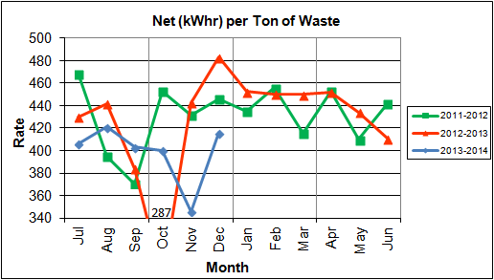

Chart 12 depicts the net power generation per processed ton. The net electrical generation per processed ton in Q2FY14 was 387 kWhr, which is 4.2% lower than the corresponding quarter in FY13.

Chart 13: Gross Turbine Generator Conversion Rate

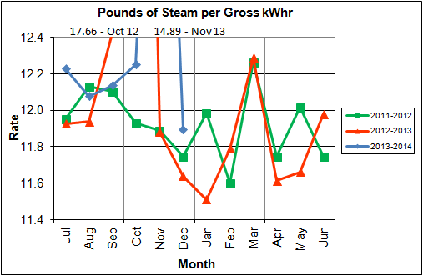

Charts 13 and 14 illustrate the quantities of steam required to generate one kWhr of electricity, gross and net respectively. This measure is a turbine generator performance indicator, where lower steam rates indicate superior performance. For simplification, this calculated rate is based on the average for the two turbine generators. In Q2FY14 the average lbs of steam consumed per gross kWhr was 12.9, which is lower (2.7%) than the corresponding quarter Q2FY13. The average lbs of steam consumed per net kWhr was 15.7, which is lower (2.1%) than the corresponding quarter in FY13. The average steam temperature during the quarter was 675.6oF, which is nearly identical to the average steam temperature of the corresponding quarter last year, and 24.4oF lower than design temperature of 700oF.

Chart 14: Net Turbine Generator Conversion Rate

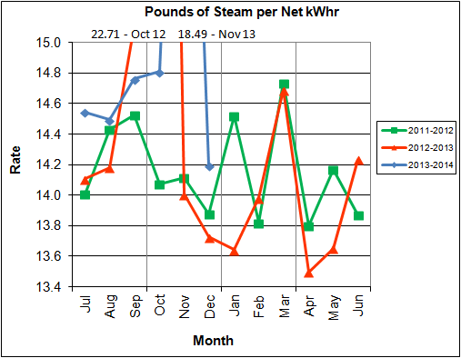

# Facility Availability

Facility availabilities for Q2FY14 are shown in Table 4. According to CAAI reports, the average unit availabilities for Boiler Nos. 1, 2, and 3 for Q2FY14 were 95.3%, 100.0%, and 95.5%, respectively. The three-boiler average availability during the quarter was 96.9%, which is good. Note that the reported unit availability percentages exclude the substantial “standby time” registered during the quarter.

During Q2FY14, the average availability for Turbine Generator Nos. 1 and 2 was 99.3% and 71.3%. The two-turbine generator average availability during the quarter was 85.3%, which is atypical when compared to historical averages but acceptable given the downtime (614.8 hours) experienced during the Turbine Generator No. 2 Overhaul in October and November 2013 which negatively impacted overall availability.

Table 4: Quarterly Facility Unit Availabilities

|  |  |  |  |
| --- | --- | --- | --- |
| **Availability** | **Q1FY14 Average** | **Q2FY14 Average** | **FY14 YTD Average** |
| Boiler No. 1 | 100.0% | 95.3% | 97.7% |
| Boiler No. 2 | 93.5% | 100.0% | 96.7% |
| Boiler No. 3 | 95.9% | 95.5% | 95.7% |
| ***Avg.*** | ***96.5%*** | ***96.9%*** | ***96.7%*** |
| Turbine No. 1 | 99.9% | 99.3% | 99.6% |
| Turbine No. 2 | 100.0% | 71.3% | 85.6% |
| ***Avg.*** | ***100.0%*** | ***85.3%*** | ***92.6%*** |

## Facility Operations

During Q2FY14, the Facility experienced one (1) instance of unscheduled downtime for the boilers totaling 14.3 hours, and two (2) instances of unscheduled downtime for the turbine generators totaling 25.8 hours. Beginning October 13, 2013, Boiler No. 1 experienced 105.0 hours of downtime for scheduled maintenance. Beginning October 28, 2013, Boiler No. 3 experienced 87.0 hours of downtime for scheduled maintenance. Boiler No. 2 executed its scheduled outage last quarter (September 2013). Beginning October 27, 2013, Turbine Generator No. 2 experienced 614.8 hours of downtime for a major overhaul. The boilers experienced eight (8) instances of standby time totaling 328.2 hours, and the turbine generators experienced five (5) instances of standby time totaling 222.7 hours during the quarter. Details of downtime events experienced during the quarter are portrayed in Tables 5 and 6 as follows:

Table 5: Boiler Downtime – Q2FY14

|  |  |  |  |  |  |  |
| --- | --- | --- | --- | --- | --- | --- |
| **Boiler Number** | **Outage Begin Date** | **Outage End Date** | | **Hours Unavailable** | **Downtime**  **Classification** | **Reason Unavailable** |
| 3 | 10/7/13 | 10/8/13 | | 14.3 | Unscheduled | Forced Draft Fan motor failure |
| 1 | 10/13/13 | 10/17/13 | | 105.0 | Scheduled | Fall 2013 Scheduled Outage |
| 1 | 10/17/13 | 10/18/13 | | 15.3 | Standby | Preventative measure taken to avoid exceeding 350,000 ton rolling 12-month process limit |
| 3 | 10/22/13 | 10/27/13 | | 125.0 | Standby | Preventative measure taken to avoid exceeding 350,000 ton rolling 12-month process limit |
| 3 | 10/28/13 | 10/31/13 | | 87.0 | Scheduled | Fall 2013 Scheduled Outage |
| 1 | 11/22/13 | 11/22/13 | | 9.5 | Standby | Repairs to deaerator trays |
| 2 | 11/22/13 | 11/22/13 | | 10.9 | Standby | Repairs to deaerator trays |
| 3 | 11/22/13 | 11/22/13 | | 13.7 | Standby | Repairs to deaerator trays |
| 1 | 12/18/13 | 12/20/13 | | 62.5 | Standby | Ferrous magnet shell change-out and process throughput limitations |
| 2 | 12/18/13 | 12/19/13 | | 30.5 | Standby | Ferrous magnet shell change-out and process throughput limitations |
| 3 | 12/29/13 | 12/31/13 | | 60.8 | Standby | Preventative measure taken to avoid exceeding 350,000 ton rolling 12-month process limit |
| **Total Unscheduled Downtime** | | | **14.3 Hours** | | | |
| **Total Scheduled Downtime** | | | **192.0 Hours** | | | |
| **Total Standby Downtime** | | | **328.2 Hours** | | | |
| **Total Downtime** | | | **534.5 Hours** | | | |

Table 6: Turbine Generator Downtime – Q2FY14

|  |  |  |  |  |  |  |
| --- | --- | --- | --- | --- | --- | --- |
| **Turbine Generator Number** | **Outage Begin Date** | **Outage End Date** | | **Hours Unavailable** | **Downtime**  **Classification** | **Reason Unavailable** |
| 2 | 10/14/13 | 10/17/13 | | 71.5 | Standby | Boiler No. 1 scheduled outage - Boiler Nos. 2 and 3 steam feeding Turbine Generator No. 1 |
| 2 | 10/23/13 | 10/26/13 | | 96.0 | Standby | Boiler No. 3 standby time for process limitations - Boiler Nos. 1 and 2 steam feeding Turbine Generator No. 1 |
| 2 | 10/27/13 | 11/21/13 | | 614.8 | Scheduled | Turbine Generator No. 2 Overhaul |
| 1 | 11/21/13 | 11/22/13 | | 15.4 | Unscheduled | Repairs to the Trip and Throttle (T&T) Dump Valve |
| 1 | 11/22/13 | 11/22/13 | | 11.7 | Standby | Boilers down for repairs to deaerator trays |
| 2 | 11/22/13 | 11/22/13 | | 10.5 | Standby | Boilers down for repairs to deaerator trays |
| 2 | 12/9/13 | 12/9/13 | | 10.4 | Unscheduled | Vibration issues during start-up after utility fault |
| 1 | 12/18/13 | 12/19/13 | | 33.0 | Standby | Lack of steam during ferrous magnet change-out |
| **Total Unscheduled Downtime** | | | **25.8 Hours** | | | |
| **Total Scheduled Downtime** | | | **614.8 Hours** | | | |
| **Total Standby Downtime** | | | **222.7 Hours** | | | |
| **Total Downtime** | | | **863.3 Hours** | | | |

As previously mentioned, scheduled maintenance was conducted during Q2FY14 on Boiler No. 1 beginning October 13, 2013, lasting 105.0 hours and on Boiler No. 2 beginning October 28, 2013, lasting 87.0 hours Some significant maintenance items conducted during the outage included:

* Installation of a globe valve in the supply piping to the Nos. 1 and 3 Attemperator Valves
* Fabrication of baffle plates from stainless steel
* Replacement of the Over Fire, Under Fire, and Seal Air Fan Motors on Boiler No. 1
* Replacement of Over Fire Air Fan Motor on Boiler No. 3
* Replacement of the Over Fire Air Nozzles on Boiler No. 1
* Replacement of 12 feed chute curved blocks on Boiler No. 1 and two (2) on Boiler No. 3
* Replacement of the triangular brake plates on Boiler Nos. 1 and 3 Feed Rams
* Re-plating of the bottom eight (8) feet on the Boiler No. 1 Feed Chute Hopper
* Replacement of the feed Ram wear Plates on Boiler Nos. 1 and 3
* Repair of the north side lower ash discharger door top hinge on Boiler No. 3
* Re-plating of numerous sections of the generating bank baffle plating on Boiler Nos. 1 and 3
* Repair of several cracks on the Boiler No. 3 Convection Pass Hopper

The Turbine Generator No. 2 Major Overhaul was conducted during Q2FY14 beginning October 27, 2013 lasting 614.8 hours. Some significant maintenance items conducted during the overhaul included:

* Installation of one (1) 10-inch and one (1) 4-inch lift check valves on the high and low pressure extraction lines
* Installation of new Turbine Water Induction Protection (TWIP) Valves on the high and low pressure extraction lines
* Installation of control and monitoring upgrades including all associated terminations, wiring, and hardware for the following:
  + Bentley Nevada Vibration and Temperature Monitoring System
  + Protech II System
  + Woodward 505 Governor Control
  + TM 25 Woodward Servo Actuator
* Removal and reinstallation of resistive thermal detectors (RTDs), vibration probes, gauges, additional speed pickups, exciter, lube oil motors, and non-return valves

In addition to the Boiler Nos. 1 and 3 outages, and Turbine Generator No. 2 Overhaul, CAAI reports that 2,268 preventative maintenance actions were completed during Q2FY14.

## Utility and Reagent Consumptions

Table 7: Facility Utility and Reagent Consumptions

|  |  |  |  |  |  |  |
| --- | --- | --- | --- | --- | --- | --- |
| **Utility** | **Units** | **Q2FY14 Total** | **Q2FY13**  **Total** | **Q2FY14”Per Processed Ton” Consumption** | **Q2FY13”Per Processed Ton” Consumption** | **FY14 YTD Total** |
| Purchased Power | MWhr | 5,618 | 5,564 | 0.07 | 0.07 | 11,282 |
| Fuel Oil | Gal. | 17,140 | 13,570 | 0.20 | 0.16 | 29,140 |
| Boiler Make-up | Gal. | 2,034,000 | 1,650,000 | 23.85 | 19.45 | 4,229,000 |
| Cooling Tower Make-up(1) | Gal. | 29,601,856 | 33,026,566 | 347.09 | 389.36 | 69,241,147 |
| Pebble Lime | Lbs. | 1,240,000 | 1,332,000 | 14.54 | 15.70 | 2,466,000 |
| Ammonia | Lbs. | 158,000 | 142,000 | 1.85 | 1.67 | 315,000 |
| Carbon | Lbs. | 100,000 | 104,000 | 1.17 | 1.23 | 204,000 |
| Dolomitic Lime | Lbs. | 160,000 | 154,000 | 1.88 | 1.82 | 542,000 |

**Note (1): CAAI reports there were issues during the month of December with the meter, resulting in a low reading.**

Fuel oil usage during the quarter represents approximately 0.31% of the total heat input to the boilers, which compares favorably with industry averages, and is slightly higher than the percentage of heat input in Q2FY13 at 0.25%. Fuel oil is used to stabilize combustion of wet fuel, as well as during start-up and shut-down of the boilers for maintenance. Boiler makeup water usage during the quarter represents 3.3% of steam flow, and is acceptable. Pebble lime usage, at 1,240,000 lbs. is lower (6.9%) than the corresponding quarter last year, and the quarterly consumption rate of 14.5 lbs/ton is below historical levels (16-18 lbs/ton).

In comparing Q2FY14 to Q2FY13 on a per processed ton consumption basis:

* the purchased power consumption rate was 0.4% higher
* the total fuel oil consumption rate was 25.6% higher
* the boiler make-up water consumption rate was 22.6% higher
* the cooling tower make-up water consumption rate was 10.9% lower
* the total pebble lime consumption rate was 7.4% lower
* the ammonia consumption rate was 10.7% higher
* the carbon consumption rate was 4.4% lower
* the total dolomitic lime consumption rate was 3.3% higher

# Environmental

The retrofit air pollution control equipment maintained emission concentrations well within the established regulations. Average Continuous Emission Monitoring System (CEMS) data collected for each monthly period during Q2FY14 are summarized in Appendix A. The Facility experienced one (1) environmental exceedance during the quarter.

On December 12, 2013, Boiler No. 2 experienced an environmental exceedance when 4-hour Carbon Monoxide (CO) levels reached 169 ppm (100 ppm limit) as a result of feeding wet waste. CAAI reports that the auxiliary burner was lit in an attempt to burn off the wet waste and control CO. Shortly after the auxiliary burners were lit, the control room operator secured the Under Fire and Over Fire Air Fans which caused a significant drop in oxygen and CO emissions in excess of 1500 ppm. The Over Fire   
Air Fan was restarted, oxygen levels returned to the normal operating range and CO emissions dropped below permit limits.

A summary of the environmental exceedance experienced by the Facility during Q2FY14 is shown in Table 8 as follows.

Table 8: Quarterly Environmental Excursions

| **Date** | **Excursion** | **Exempt** |
| --- | --- | --- |
| 12/13/13 | Boiler No. 2 4-hour CO levels reached 169 ppm (100 ppm limit) | No |

## Nitrogen Oxide Emissions

During Q2FY14, the monthly emission concentrations of nitrogen oxides (NOx) averaged 170.3 ppmdv, 160.0 ppmdv and 162.7 ppmdv for Boiler Nos. 1, 2, and 3, respectively. CAAI continues to operate the units at the lower (160 ppmdv) set-points, except immediately following a scheduled outage and associated boiler cleaning.

## Sulfur Dioxide Emissions

During Q2FY14 the monthly emission concentration of stack sulfur dioxide (SO2) averaged 0.7 ppmdv, 0.3 ppmdv, and 0.3 ppmdv for Boiler Nos. 1, 2, and 3, respectively. All of these stack SO2 concentrations are significantly below the 40 CFR Subpart Cb requirement of 29 ppmdv @ 7% O2.

## Carbon Monoxide Emissions

During Q2FY14, the average CO emission concentrations on Boiler Nos. 1, 2, and 3 were 36.7 ppmdv, 35.7 ppmdv, and 26.3 ppmdv, respectively, and all are well within permit limits (100 ppmdv, hourly average).

## Opacity

During Q2FY14, the average opacity for Boiler Nos. 1, 2, and 3 was 0.3%, 1.1%, and 0.1% respectively. All of these averages are significantly below the 10% (6-minute) average permit limit.

## Daily Emissions Data

Appendix A, Tables 11, 12, 13 tabulate the monthly average, maximum, and minimum emissions data for each unit during Q2FY14. Excursions, if any, would appear in bold print. It should be noted that these tabulations of monthly averages, reported here for informational purposes, are based on tabulations of daily averages. These averages do not correlate with official reports to the regulatory agencies because of differences in averaging times and other technical differences required by agency report formats.

## Ash System Compliance

The dolomitic lime feed rate is adjusted periodically in order to maintain a desired ash pH level in the range of 8.0 to 11.0. Since initial startup, the feed rate has varied from between 4 to 9 lbs per ton. Ash Toxicity (TCLP) tests were performed for field samples collected over a seven (7) day period in November 2013, and results indicate that the average pH during testing was 9.7. Results from the TCLP testing conducted in November 2013 are depicted in Table 9 and Chart 15 below.

Table 9: Comparison of Statistical Results and Regulatory Thresholds for Metal Analytes

|  |  |  |  |  |  |
| --- | --- | --- | --- | --- | --- |
| **Metals** | **90% Upper Confidence**  **(November 2013)** | **90% Upper Confidence**  **(May 2013)** | **Regulatory Threshold (mg/L)** | **% of Threshold (November 2013)** | **% of Threshold**  **(May 2013)** |
| **Arsenic** | 0.250 | 0.250 | 5.0 | 5.00% | 5.00% |
| **Barium** | 1.050 | 0.910 | 100.0 | 1.05% | 0.91% |
| **Cadmium** | 0.082 | 0.050 | 1.0 | 8.20% | 5.00% |
| **Chromium** | 0.250 | 0.250 | 5.0 | 5.00% | 5.00% |
| **Lead** | 0.300 | 0.250 | 5.0 | 6.00% | 5.00% |
| **Mercury** | 0.0003 | 0.0002 | 0.2 | 0.15% | 0.10% |
| **Selenium** | 0.050 | 0.050 | 1.0 | 5.00% | 5.00% |
| **Silver** | 0.250 | 0.250 | 5.0 | 5.00% | 5.00% |

Chart 15: Ash Toxicity Characteristic Leaching Procedure (TCLP) Results

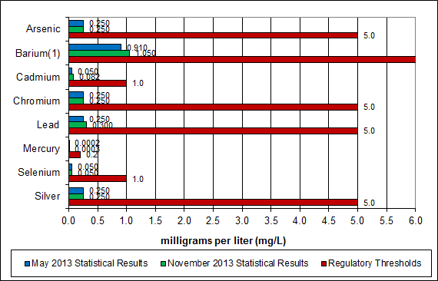

**Note: The regulatory threshold for Barium is 100 mg/L**

CAAI also samples ash monthly, and documents pH reading to adjust dolomitic lime feed rate. The results for the ash pH tests are found below in Chart 16 where each quarter is represented by the average of the respective monthly readings. During Q2FY14, the average ash pH for in-house tests was 9.5.

Chart 16: Quarterly Ash Test Results

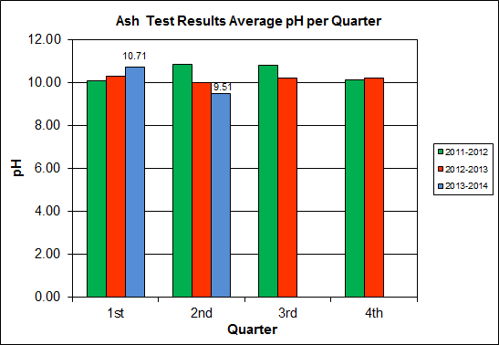

## Steam Production Issues

In October, 2007, VADEQ issued CAAI a “Warning Letter” (WL) regarding alleged violations of Condition 14 of the Facility’s Prevention of Significant Deterioration (PSD) permit issued in 2002. In response to the WL, CAAI recalculated annual steam production totals according to the VADEQ’s methodology which was to track the annual limit on a monthly basis, by adding the current month’s production to the previous 11 months’ total, and comparing it to the annual 1.12 million ton limit (Previously, CAAI tracked the annual limit on a calendar year basis, and not monthly). The recalculated data showed that the Facility exceeded the steam production limits on several occasions. Although there were not any exceedances of air emissions at the Facility, VADEQ issued a Notice of Violation (NOV) on February 29, 2008.

In March 2009, CAAI and VADEQ entered into a letter of agreement (LOA) to resolve the alleged violations. The tenets of the agreement stipulate that:

The annual steam production for the Facility shall not exceed 1,170,400 tons on the basis of an average value of 3.34 lbs of steam per lb of MSW processed, calculated monthly as the sum of each consecutive 12 month period, as compared to the measured totalized steam flow that was previously used.

Chart 5 on page 11 depicts the steam production total calculated monthly as the sum of each consecutive 12-month period.

While the agreement with DEQ settled a long-standing issue and clarifies the methodology to be used, HDR considers it to be a flawed approach, and not consistent with general industry practice. The DEQ approach relies on a more-subjective method of calculating steam flow based on the tonnage of waste processed. Determination of monthly tonnage of waste processed relies on estimates of the quantity of waste in the pit, based only on visual observation. In addition, it is well known that waste at the bottom of the pit has significantly higher density (weight per volume) than that at the top of the pit, and this is not factored into the monthly tonnage. Finally, the conversion of MSW tonnage to steam production ignores the variability in calculated waste heating value.

According to CAAI data, the waste processed each month during Q2FY14 was limited by the steam production limit and substantial downtime (standby time) was used to stay below the limit.

# Facility Maintenance

Throughout the quarter, significant routine and planned maintenance was performed. HDR considers that the Facility is implementing an effective maintenance regimen, and is performing routine and preventative maintenance, along with selected equipment replacements in a timely manner. CAAI monthly maintenance reports provide a detailed account of maintenance performed.

## Safety

The plant had no recordable accidents during the quarter. The plant has operated 1,139 days without an OSHA recordable incident through the end of December 2013. Safety training was conducted during the quarter with themes as follows:

October 2013 – Electrical Safety and Changes to Safety Procedure 23A-1

November 2013 - Global Harmonization System

December 2013 – Walking and Working Surfaces, Fall Protection and Solid Waste Part 2

## Facility Housekeeping

CAAI is performing Facility housekeeping and maintaining plant cleanliness in accordance with acceptable industry practices. A Site inspection was conducted in November 2013. At the time of the inspection, new deficiencies were recorded and prior deficiencies were given a status update. Photos of interest from the inspection are depicted in Appendix B. The Facility housekeeping ratings from the November 2013 inspection are presented in Table 10.

Table 10: Facility Housekeeping Ratings – November 2013

| **Facility Area** | **Highly Acceptable** | **Acceptable** | **Needs Improvement** | **Unacceptable** |
| --- | --- | --- | --- | --- |
| Tipping Floor |  | √ |  |  |
| Citizen’s Drop-off Area |  | √ |  |  |
| Tipping Floor Truck Exit |  | √ |  |  |
| Front Parking Lot |  | √ |  |  |
| Rear Parking Lot |  | √ |  |  |
| Boiler House Pump Room |  | √ |  |  |
| Lime Slurry Pump Room |  | √ |  |  |
| Switchgear Area |  | √ |  |  |
| Ash Load-out Area |  | √ |  |  |
| Vibrating Conveyor Area | √ |  |  |  |
| Ash Discharger Area |  | √ |  |  |
| Cooling Tower Area |  | √ |  |  |
| Truck Scale Area |  | √ |  |  |
| SDA/FF Conveyor Area |  | √ |  |  |
| SDA Penthouses |  | √ |  |  |
| Lime Preparation Area |  | √ |  |  |
| Boiler Drum Levels |  | √ |  |  |
| Turbine Room | √ |  |  |  |
| Electrical Room |  | √ |  |  |

APPENDIX A  
FACILITY CEMS DATA

Table 11: Unit #1 Monthly Summary for Reportable Emissions Data

|  |  |  |  |  |  |  |  |  |  |  |
| --- | --- | --- | --- | --- | --- | --- | --- | --- | --- | --- |
| **Group#-Channel#** | | **G8-C35** | **G8-C28** | **G8-C8** | **G8-C4** | **G8-C12** | **G8-C34** | **G8-C37** | **G8-C40** | **G8-C39** |
| **Long Descrip.** | | **U-1 Steam** | **U-1 Econ** | **U-1 Stack** | **U-1 Stack** | **U-1 Stack** | **U-1 Opaci** | **U-1 FF In** | **U-1 Carbo** | **U-1 Lime** |
| **Short Descrip.** | | **SteamFl** | **SO2ec** | **SO2sc** | **COsc** | **NOxsc** | **Opacity** | **FF InTemp** | **CarbInj** | **LimeFlow** |
| **Units** | | **K#/Hr** | **ppmc** | **ppm** | **ppmc** | **ppmc** | **%** | **deg F** | **#/hr** | **gpm** |
| **Range** | | **0-100** | **0-2000** | **0-500** | **0-4000** | **0-1000** | **0-100** | **100-500** | **0-50** | **0-20** |
| Oct-13 | AVG | 88.5 | 67.0 | 2.0 | 35.0 | 185.0 | 0.3 | 302.0 | 16.5 | 3.3 |
| Max | 92.3 | 91.0 | 8.0 | 48.0 | 189.0 | 0.7 | 310.0 | 17.4 | 3.5 |
| Min | 81.9 | 41.0 | 0.0 | 28.0 | 166.0 | 0.0 | 302.0 | 16.1 | 3.0 |
| Nov-13 | AVG | 83.0 | 38.0 | 0.0 | 37.0 | 166.0 | 0.3 | 302.0 | 16.4 | 2.9 |
| Max | 90.1 | 58.0 | 2.0 | 50.0 | 189.0 | 0.9 | 309.0 | 17.5 | 3.3 |
| Min | 58.7 | 22.0 | 0.0 | 9.0 | 164.0 | 0.0 | 302.0 | 16.0 | 2.4 |
| Dec -13 | AVG | 81.7 | 29.0 | 0.0 | 38.0 | 160.0 | 0.4 | 302.0 | 16.7 | 2.8 |
| Max | 88.7 | 47.0 | 1.0 | 54.0 | 162.0 | 0.8 | 305.0 | 17.9 | 3.1 |
| Min | 69.8 | 15.0 | 0.0 | 22.0 | 154.0 | 0.1 | 299.0 | 16.3 | 2.4 |
| **Quarter Average** | | 84.4 | 44.7 | 0.7 | 36.7 | 170.3 | 0.3 | 302.0 | 16.5 | 3.0 |
| **Quarter Max Value** | | 92.3 | 91.0 | 8.0 | 54.0 | 189.0 | 0.9 | 310.0 | 17.9 | 3.5 |
| **Quarter Min Value** | | 58.7 | 15.0 | 0.0 | 9.0 | 154.0 | 0.0 | 299.0 | 16.0 | 2.4 |
| **Limits:** | | NA | NA | 29 | 100 | 205 | 10 | 320 | 16(a) |  |

(a) Carbon flow limit is a minimum value

* Note: The data reported herein represent 24 hour average data for all parameters. Emissions excursions that are measured on shorter time intervals (ie., 4-hour block averages for CO) do not correlate with the 24 hour average data reported above.

Table 12: Unit #2 Monthly Summary for Reportable Emissions Data

|  |  |  |  |  |  |  |  |  |  |  |
| --- | --- | --- | --- | --- | --- | --- | --- | --- | --- | --- |
| **Group#-Channel#** | | **G8-C35** | **G8-C28** | **G8-C8** | **G8-C4** | **G8-C12** | **G8-C34** | **G8-C37** | **G8-C40** | **G8-C39** |
| **Long Descrip.** | | **U-2 Steam** | **U-2 Econ** | **U-2 Stack** | **U-2 Stack** | **U-2 Stack** | **U-2 Opaci** | **U-2 FF In** | **U-2 Carbo** | **U-2 Lime** |
| **Short Descrip.** | | **SteamFl** | **SO2ec** | **SO2sc** | **COsc** | **NOxsc** | **Opacity** | **FF InTemp** | **CarbInj** | **LimeFlow** |
| **Units** | | **K#/Hr** | **ppmc** | **ppm** | **ppmc** | **ppmc** | **%** | **deg F** | **#/hr** | **gpm** |
| **Range** | | **0-100** | **0-2000** | **0-500** | **0-4000** | **0-1000** | **0-100** | **100-500** | **0-50** | **0-20** |
| Oct-13 | AVG | 89.8 | 67.0 | 1.0 | 35.0 | 164.0 | 0.5 | 297.0 | 16.5 | 3.2 |
| Max | 92.6 | 89.0 | 9.0 | 42.0 | 178.0 | 1.3 | 299.0 | 18.7 | 3.6 |
| Min | 82.7 | 37.0 | 0.0 | 24.0 | 157.0 | 0.0 | 295.0 | 16.1 | 2.7 |
| Nov-13 | AVG | 84.3 | 40.0 | 0.0 | 35.0 | 159.0 | 1.7 | 297.0 | 16.3 | 2.7 |
| Max | 92.0 | 54.0 | 1.0 | 47.0 | 181.0 | 3.7 | 299.0 | 17.0 | 3.1 |
| Min | 60.6 | 20.0 | 0.0 | 16.0 | 150.0 | 0.2 | 297.0 | 16.2 | 2.3 |
| Dec -13 | AVG | 82.8 | 33.0 | 0.0 | 37.0 | 157.0 | 1.2 | 297.0 | 16.3 | 2.7 |
| Max | 91.1 | 55.0 | 3.0 | 57.0 | 159.0 | 3.6 | 298.0 | 16.8 | 3.0 |
| Min | 70.6 | 25.0 | 0.0 | 22.0 | 151.0 | 0.3 | 296.0 | 16.1 | 2.3 |
| **Quarter Average** | | 85.6 | 46.7 | 0.3 | 35.7 | 160.0 | 1.1 | 297.0 | 16.4 | 2.9 |
| **Quarter Max Value** | | 92.6 | 89.0 | 9.0 | 57.0 | 181.0 | 3.7 | 299.0 | 18.7 | 3.6 |
| **Quarter Min Value** | | 60.6 | 20.0 | 0.0 | 16.0 | 150.0 | 0.0 | 295.0 | 16.1 | 2.3 |
| **Limits:** | | NA | NA | 29 | 100 | 205 | 10 | 320 | 17(a) |  |

(a) Carbon flow limit is a minimum value

* Note: The data reported herein represent 24 hour average data for all parameters. Emissions excursions that are measured on shorter time intervals (ie., 4-hour block averages for CO) do not correlate with the 24 hour average data reported above.

Table 13: Unit #3 Monthly Summary for Reportable Emissions Data

|  |  |  |  |  |  |  |  |  |  |  |
| --- | --- | --- | --- | --- | --- | --- | --- | --- | --- | --- |
| **Group#-Channel#** | | **G8-C35** | **G8-C28** | **G8-C8** | **G8-C4** | **G8-C12** | **G8-C34** | **G8-C37** | **G8-C40** | **G8-C39** |
| **Long Descrip.** | | **U-3 Steam** | **U-3 Econ** | **U-3 Stack** | **U-3 Stack** | **U-3 Stack** | **U-3 Opaci** | **U-3 FF In** | **U-3 Carbo** | **U-3 Lime** |
| **Short Descrip.** | | **SteamFl** | **SO2ec** | **SO2sc** | **COsc** | **NOxsc** | **Opacity** | **FF InTemp** | **CarbInj** | **LimeFlow** |
| **Units** | | **K#/Hr** | **ppmc** | **ppm** | **ppmc** | **ppmc** | **%** | **deg F** | **#/hr** | **gpm** |
| **Range** | | **0-100** | **0-2000** | **0-500** | **0-4000** | **0-1000** | **0-100** | **100-500** | **0-50** | **0-20** |
| Oct-13 | AVG | 84.6 | 43.0 | 0.0 | 28.0 | 160.0 | 0.1 | 296.0 | 16.2 | 3.2 |
| Max | 91.5 | 93.0 | 1.0 | 56.0 | 175.0 | 1.0 | 304.0 | 17.4 | 3.5 |
| Min | 75.3 | 23.0 | 0.0 | 18.0 | 148.0 | 0.0 | 295.0 | 16.0 | 2.7 |
| Nov-13 | AVG | 85.7 | 46.0 | 1.0 | 27.0 | 169.0 | 0.1 | 302.0 | 16.1 | 3.0 |
| Max | 93.2 | 73.0 | 3.0 | 46.0 | 186.0 | 0.9 | 304.0 | 16.9 | 3.4 |
| Min | 60.0 | 20.0 | 0.0 | 3.0 | 156.0 | 0.0 | 301.0 | 16.0 | 2.5 |
| Dec -13 | AVG | 85.3 | 31.0 | 0.0 | 24.0 | 159.0 | 0.2 | 303.0 | 16.2 | 2.9 |
| Max | 90.0 | 45.0 | 2.0 | 38.0 | 174.0 | 0.5 | 303.0 | 16.7 | 3.4 |
| Min | 74.9 | 10.0 | 0.0 | 9.0 | 155.0 | 0.0 | 302.0 | 16.0 | 2.5 |
| **Quarter Average** | | 85.2 | 40.0 | 0.3 | 26.3 | 162.7 | 0.1 | 300.3 | 16.2 | 3.0 |
| **Quarter Max Value** | | 93.2 | 93.0 | 3.0 | 56.0 | 186.0 | 1.0 | 304.0 | 17.4 | 3.5 |
| **Quarter Min Value** | | 60.0 | 10.0 | 0.0 | 3.0 | 148.0 | 0.0 | 295.0 | 16.0 | 2.5 |
| **Limits:** | | NA | NA | 29 | 100 | 205 | 10 | 320 | 16(a) |  |

(a) Carbon flow limit is a minimum value

* Note: The data reported herein represent 24 hour average data for all parameters. Emissions excursions that are measured on shorter time intervals (ie., 4-hour block averages for CO) do not correlate with the 24 hour average data reported above.

APPENDIX B  
SITE PHOTOS – NOVEMBER 12, 2013

|  |  |
| --- | --- |
| E:\Alexandria Arlington\Alexandria Arlington - Q2FY14\November 2013\PB120002.JPG  Figure 1: Turbine Generator No. 2 Major Overhaul – Upper Half 15th Stage Diaphragm – removed for inspection | E:\Alexandria Arlington\Alexandria Arlington - Q2FY14\November 2013\PB120010.JPG  Figure 2: Turbine Generator No. 2 Major Overhaul -overhead photo of removed rotor |
| E:\Alexandria Arlington\Alexandria Arlington - Q2FY14\November 2013\PB120011.JPG  Figure 3: Turbine Generator No. 2 Major Overhaul – various stages of packing removed for inspection | E:\Alexandria Arlington\Alexandria Arlington - Q2FY14\November 2013\PB120013.JPG  Figure 4: Turbine Generator No. 2 Major Overhaul – isometric view of removed rotor |
| E:\Alexandria Arlington\Alexandria Arlington - Q2FY14\November 2013\PB120030.JPG  Figure 5: Turbine Generator No. 2 Major Overhaul – scaffolding in place for Main Condenser No. 2 work | E:\Alexandria Arlington\Alexandria Arlington - Q2FY14\November 2013\PB120035.JPG  Figure 6: Turbine Generator No. 2 Major Overhaul – Contractors removing lower diaphragms for inspection |
| E:\Alexandria Arlington\Alexandria Arlington - Q2FY14\November 2013\PB120037.JPG  Figure 7: Turbine Generator No. 2 Major Overhaul – Upper Turbine Shell Removed | E:\Alexandria Arlington\Alexandria Arlington - Q2FY14\November 2013\PB120033.JPG  Figure 8: Turbine Generator No. 2 Major Overhaul – Turbine controls being upgraded – face removed for rewiring |
| E:\Alexandria Arlington\Alexandria Arlington - Q2FY14\November 2013\PB120040.JPG  Figure 9: Turbine Generator No. 2 Major Overhaul – Upper Half 8th Stage Diaphragm – removed for inspection | E:\Alexandria Arlington\Alexandria Arlington - Q2FY14\November 2013\PB120007.JPG  Figure 10: Turbine Generator No. 2 Major Overhaul – upper shell, rotor, diaphragms, and packing removed |
| E:\Alexandria Arlington\Alexandria Arlington - Q2FY14\November 2013\PB120009.JPG  Figure 11: Turbine Generator No. 2 Major Overhaul – General View – Lower shell casing and studs | E:\Alexandria Arlington\Alexandria Arlington - Q2FY14\November 2013\PB120003.JPG  Figure 12: Turbine Generator No. 2 Major Overhaul – various packing removed for inspection |
| E:\Alexandria Arlington\Alexandria Arlington - Q2FY14\November 2013\PB120016.JPG  Figure 13: General Facility view from across Eisenhower Avenue | E:\Alexandria Arlington\Alexandria Arlington - Q2FY14\November 2013\PB120022.JPG  Figure 14: Citizen’s Drop-off Roll-off nearly full |
| E:\Alexandria Arlington\Alexandria Arlington - Q2FY14\November 2013\PB120021.JPG  Figure 15: General Facility view from entrance roadway | E:\Alexandria Arlington\Alexandria Arlington - Q2FY14\November 2013\PB120024.JPG  Figure 16: Spider cracking and concrete repairs showing continued degradation (Deficiency Item No. 1 – July 2010) |
| E:\Alexandria Arlington\Alexandria Arlington - Q2FY14\November 2013\PB120027.JPG  Figure 17: White Goods Roll-Off | E:\Alexandria Arlington\Alexandria Arlington - Q2FY14\November 2013\PB120025.JPG  Figure 18: Inbound Scale – No Issues Observed |
| E:\Alexandria Arlington\Alexandria Arlington - Q2FY14\November 2013\PB120028.JPG  Figure 19: Ash Trailers – No Issues Observed | E:\Alexandria Arlington\Alexandria Arlington - Q2FY14\November 2013\PB120031.JPG  Figure 20: Cooling Towers – Photos from SDA Penthouse |
| E:\Alexandria Arlington\Alexandria Arlington - Q2FY14\November 2013\PB120032.JPG  Figure 21: Auxiliary Burner – No Issues Observed | E:\Alexandria Arlington\Alexandria Arlington - Q2FY14\November 2013\PB120050.JPG  Figure 22: Tipping Floor – No Issues Observed |
| E:\Alexandria Arlington\Alexandria Arlington - Q2FY14\November 2013\PB120048.JPG  Figure 23: Main Vibratory Conveyor – No Issues Observed | E:\Alexandria Arlington\Alexandria Arlington - Q2FY14\November 2013\PB120046.JPG  Figure 24: Ferrous Metal Load-Out – No Issues Observed |